CGT 270
How We Feed Billions
Team Done
Tommy Hochstetler, Derick Zhen, Kaden Bray, and Russell Thomas
11-30-2023

How We Feed Billions
Team name: Done
Name (full name) | Purdue Email address
Tommy Hochstetler | Thochste@purdue.edu
Derick Zhen | Dzhen@purdue.edu
Kaden Bray | Bray14@purdue.edu
Russell Thomas | Thom1148@purdue.edu

Table of Contents
Introduction 2
Background 2
Questions 2
Problem Statement 2
Methodology 3
Results 3
Discussion and Conclusion 3
References 4
Appendix A – Resources Used 5
Datasets 5
Tools used 5
Appendix B – Percent Contribution 6
Group Contributions 6
Individual Contributions 6
Appendix C – Individual Contributions 7
Team Member #1: <replace this text with Team Member’s full name> 8
Team Member #2: <replace this text with Team Member’s full name> 9
Team Member #3: <replace this text with Team Member’s full name> 10
Team Member #4: <remove this page if the team has less than 4 members> 12
Appendix E – Team Consensus 14
Team Consensus 14

How We Feed Billions

Introduction
For our research to choose to visualize crop production in America and America’s Imports for the year 2022. We will touch on four main crops those being corn, soybean, tobacco, and wheat. With each crop we will cover measurements such as production, yield, acres planted, and exports.

Background
In this section provide background about the data – what dataset did the team choose and why? What additional data was acquired by the team? Why? Explain.
In 2022, the USDA supplied payments of $800 million in assistance to help farmers keep farming. This $800 million was part of the $3.1 billion in assistance for distressed farm loan borrowers. A lot of this money is dedicated to farmers who are in extreme debt from purchasing feed and different equipment that helps them produce their crops or maintain the well-being of their animals. It is very expensive to be able to maintain land and produce crops. A lot of the different machines cost hundreds of thousands of dollars and may take years to pay off.
Looking at the world, and not only the US, the United Nations Environmental Program broke down the topic of agriculture amongst the entire world. It was described that there is enough food to feed 10 billion people, let alone 8 billion people. Although solving world hunger has stagnated over the past 5 years, the problem stems from efficiency rather than a lack of food in general. Land is not always used efficiently to utilize the maximum amount of production. An absolutely absurd fact presented by the UN is that one third of all produce production is wasted between farm and table. Food is being stored, transported, processed, packaged, sold and prepared, with food being produced faster than it can be consumed in some countries. This ultimately results in about 1.3 billion tons of food being lost or wasted each year.

Questions
What is the question(s) the team has chosen to address? Who is your audience? – What problem are you trying to solve or address? What’s been done before?
The question that we are trying to answer is how vast America’s agricultural economy is and the source of our crops. Our audience is targeted to those in the agricultural sector, but we also want to display our data in an easy-to-read fashion that will allow the everyday person to understand how essential agriculture is to our economy. The problem we are addressing is that people don’t know a lot about Agriculture and its impact. What has been done before

Problem Statement
How has the data been visualized before? Significance (why should anyone care)? – why is the team’s work important?
Agriculture is the backbone of many economies throughout America, and it is important to understand their production value. It is also important to recognize how much production America has vs what America imports. The team’s work is important because without agriculture we wouldn’t be able to exist.

Methodology
What did the team do? Show your process, include sketches
How our team conducted our research was first we defined what crops we wanted to cover. We settled on corn, soybean, wheat, and tobacco as the crops to focus on. Initially we wanted to cover those crops worldwide in their production and imports/exports. After our initial research we came to conclusion that there was too much data for us to handle and process so we made the decision to only cover crops primarily in America. Our next goal was to acquire the data and we used the USDA’s statistical tool to acquire all of our data. This government website covers all records from acres planted to how much was sold in a given year for all crops. Now that we had acquired our data, we imported it into Excel to break it down and rebuild it with our visualizations.

Results
Choose one of your team’s “BEST” visualization and insert it here. This visualization should be the best representation of the team’s effort. Provide a figure caption. This section should only contain the visualization and the figure caption. This section should contain the team’s original work, not a comparison of the previous work of others.
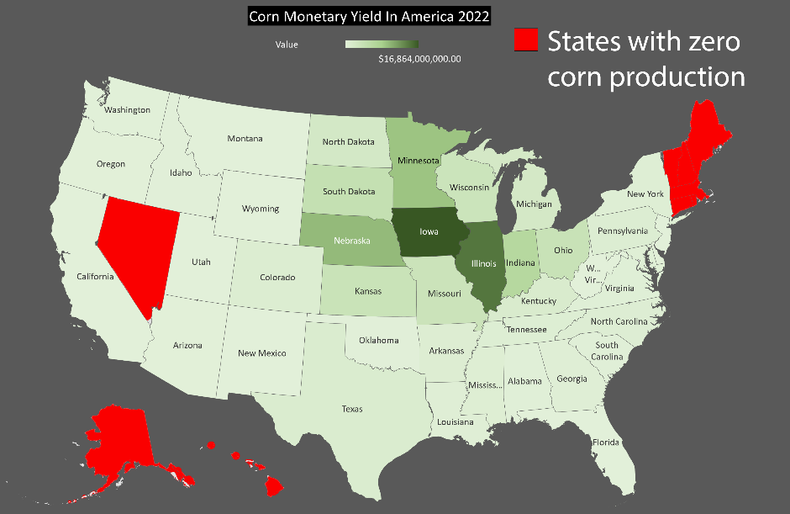
Figure 1 Corn monetary yield in America 2022 Russell Thomas

Discussion and Conclusion
Discuss your results (the figures in the Results section). Do your visualizations address the problem stated in the Problem Statement Section? Explain.
Our visualizations do address the problem that we stated because it conveys how vast and essential agriculture is to America’s economy. Insights that our team uncovered was how large the industry really is with billions of dollars in this industry. Recommendations that we can make based on our insights is that agriculture while not as exciting as new technologies such as AI or VR is still an important industry with a vast market behind it.

References
USDA/NASS 2022 State Agriculture Overview for Indiana. (n.d.). Retrieved November 28, 2023, from https://www.nass.usda.gov/Quick_Stats/Ag_Overview/stateOverview.php?state=INDIANA
We Already Grow Enough Food for 10 Billion People … and Still Can’t End Hunger. (n.d.). Retrieved October 19, 2023, from https://www.tandfonline.com/doi/epdf/10.1080/10440046.2012.695331?needAccess=true
Hobbs, P. R. (2007). PAPER PRESENTED AT INTERNATIONAL WORKSHOP ON INCREASING WHEAT YIELD POTENTIAL, CIMMYT, OBREGON, MEXICO, 20–24 MARCH 2006 Conservation agriculture: What is it and why is it important for future sustainable food production? The Journal of Agricultural Science, 145(02), 127. https://doi.org/10.1017/S0021859607006892
USDA Provides Payments of nearly $800 Million in Assistance to Help Keep Farmers Farming. (2022, October 18). [Page]. National-Post-News-Release. https://fsa.usda.gov/news-room/news-releases/2022/usda-provides-payments-of-nearly-800-million-in-assistance-to-help-keep-farmers-farming
How to feed 10 billion people. (n.d.). Retrieved October 19, 2023, from https://www.unep.org/news-and-stories/story/how-feed-10-billion-people
USDA/NASS QuickStats Ad-hoc Query Tool. (n.d.). Retrieved November 28, 2023, from https://quickstats.nass.usda.gov/

Appendix A – Resources Used

Datasets
List the name of the data set provided and a description of the additional data set acquired.

Tools used
List all tools used in the project and a brief description (see the examples below); add more if applicable.
Tool/Application | Description
Excel | Data cleaning, Data visualization
PowerPoint | Slides
Word | Documentation
Wix | Website
Final Cut Pro | Video Editing

Appendix B – Percent Contribution

Group Contributions
In this section list the tasks that were completed by all team members for example: contributed to the data visualization process, brainstormed topic ideas, served as rotating team leader, contributed content to the short story (summary), contributed content to the 5-minute video, reading the final deliverable before submission,
Individual Contributions
In the table below list each team member’s full name, their contribution (body of work) and their % of the work completed. The total must add up to 100%
Team Member | Description | Contribution
Tommy Hochstetler | Acquired the data and created a visualization for tobacco production. | 25%
Russell Thomas | Gathered data on corn production, created visualizations, and created final website | 25%
Derick Zhen | Found data on wheat production, created a visualization and the final video presentation | 25%
Kaden Bray |  | 25%
 | Total | 100%

Appendix C – Individual Contributions
In this appendix each team member must contribute a one-page document relating the team’s topic/data to their home town or home country. The one-page document must contain: (1) a description of the problem, (2) a comparison of the team’s findings with insights about your home town/country related to the teams group project data (3) a visualization to support items (1) and (2).
Each person should create their individual page (1-page only) and make it available to the designated team member who will upload the final document.
This will be viewed and assessed as part of each person’s individual contribution.
Leave this page as is.
Start adding individual page content on the next page.
REMOVE any blank pages before submitting.

Team Member #1: Tommy Hochstetler
My Hometown/City/Country: Fishers/United States Group Topic (dataset):
Include your story and visualization below.
- For my data set I chose tobacco production sales by state within the United States. I gathered my data from the National Agricultural Statistics Service located on the United States Department of Agriculture’s Quick Stats cite. There were many ways to filter the data set and there were 3 categories of filtering. The first stage was Commodity and I selected within Program: Survey, Sector: Crops, Group: Field Crops, Commodity: Tobacco, Category: Production, Data Item: Tobacco – Production, Measured in $, Domain: Total. The second stage was Location and I selected within Geographic Level: National, State: US Total. The third and last stage was Time, and I chose within Year: 2022, Period Type: Annual, Period: Year. This then gave me a data set I can work with that is completely filtered to what I need.
- I grew up around farmland which made this topic relevant to me. Even though I was still technically in a suburb, I was at the edge where there was still farmland. It was mainly corn or soybeans though and that is why I wanted to learn about a different crop and so I chose tobacco. I found it surprising how little states actually grow tobacco.
- For my visualization I chose to only show the states that grow tobacco and show which ones grow more or less. I gave it a gradient and displayed the name of the state as well as their total earnings from tobacco in 2022.

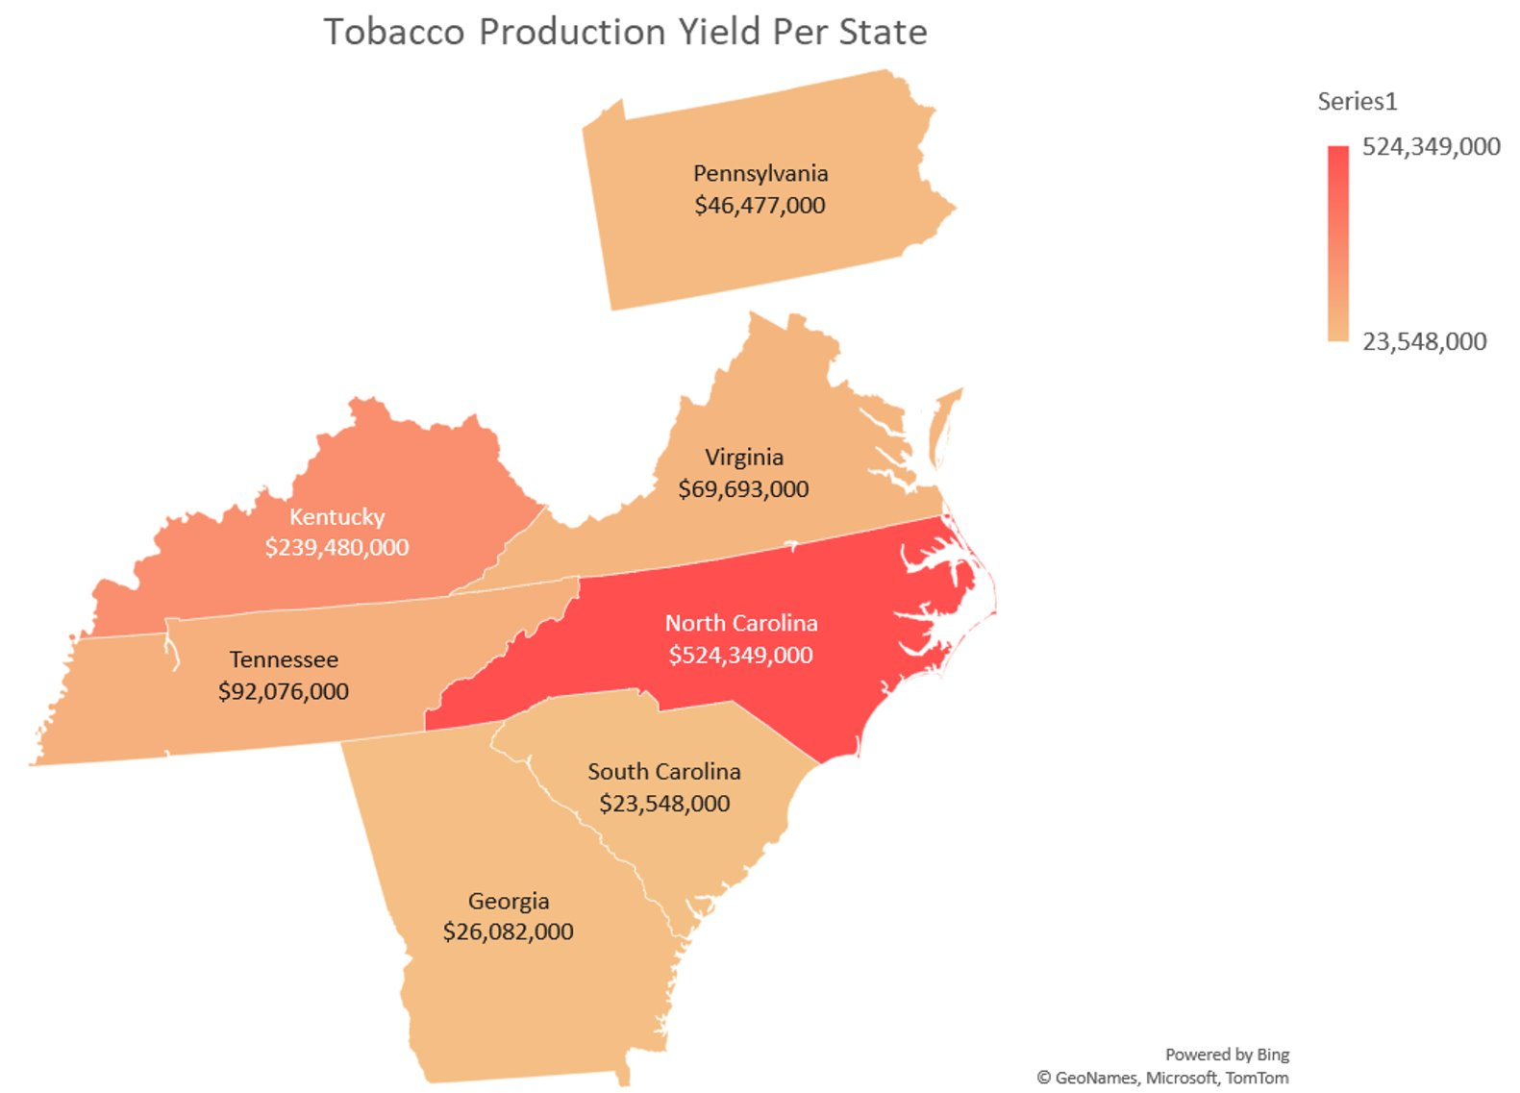

Team Member #2: Derick Zhen
My Hometown/City/Country: Warsaw, Indiana /USA Group Topic (dataset):
Include your story and visualization below.
(1) a description of the problem
What is the production of wheat like in the United States, and even the other top counties in terms of wheat production. And once finding that data what is the amount and the overall value of the wheat that the United States produced. And within that amount what states are the one that produce the most wheat and the value behind those certain states.
(2) a comparison of the team’s findings with insights about your hometown/country related to the teams group project data
My heritage comes from China and my family on my mom’s side come from a farmer's background and the main reason why this helps and gives me some insight into this project is that it gives me info and context on what and where China stands in terms of agriculture
(3) a visualization to support items (1) and (2).
The first chart mainly shows international how the United States stands in terms of wheat production and after seeing that China is the one on top and giving my heritage from China and talking about it to my family members who there farmers who have immigrated from China to the United States it help give me context on how China is number one in wheat production
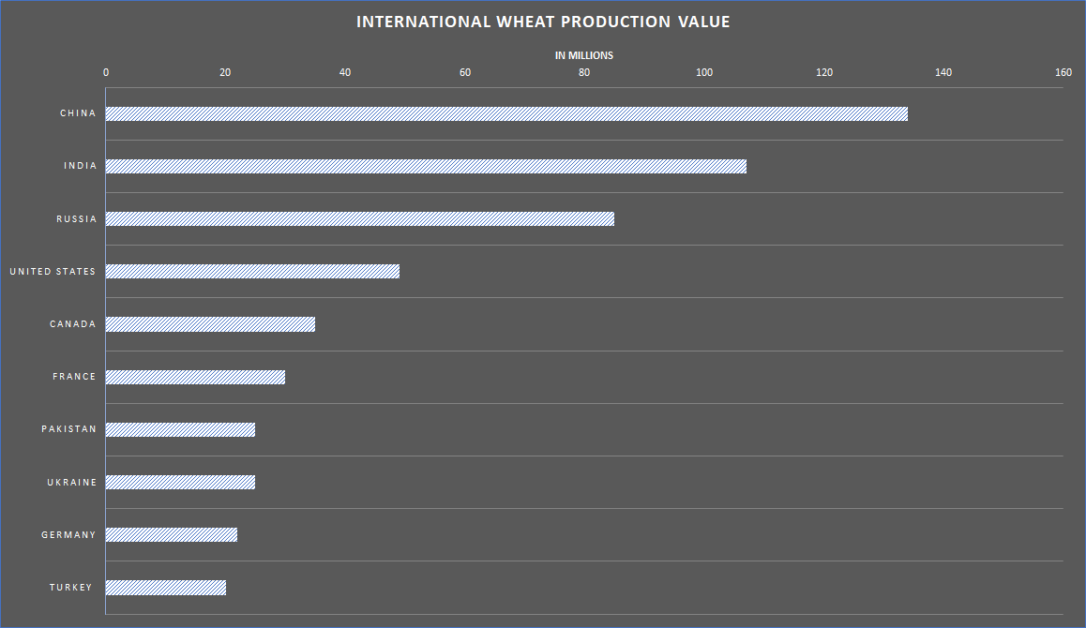
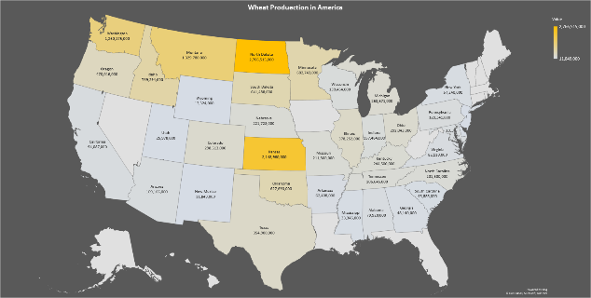

Team Member #3: Russell Thomas
My Hometown/City/Country: Michigan City, Indiana U.S. Group Topic (dataset):
Include your story and visualization below.
- For my first visualization I covered the monetary value of corn yields in America for the year 2022. I acquired my data through the official National Agricultural Statistics Service. This is hosted on the United States Department of Agriculture’s government website. The data I sourced was for each state's Corn production measured in dollars. I then applied a heat map over the country to visualize which states have the most money in corn production. This allows me to draw insights on which states are the most profitable in corn production in the year 2022.
- My second visualization was centered also around corn but rather the amount of corn that was harvested measured in Acres. For reference an acre is used to measure land, and a football field equals about 1.32 acres.
- I found this data relevant to me as I have lived in Indiana all my life. I have also been involved with agriculture my entire life as well. My family has lived on farms for generations and has had a major influence on my life. Also, because of this I wanted to show how vast agriculture is. It is not just in Indiana, but the Unites States as a whole has lots of agricultural production. Agriculture is a vital part of our economy and I feel that it is not recognized enough for its importance.
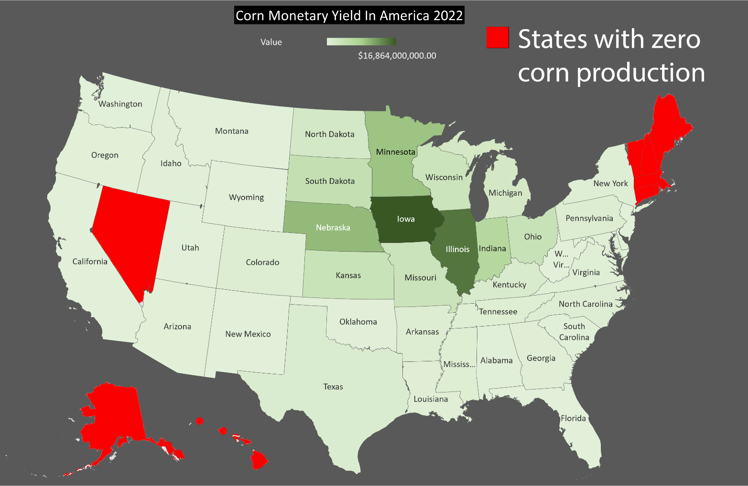

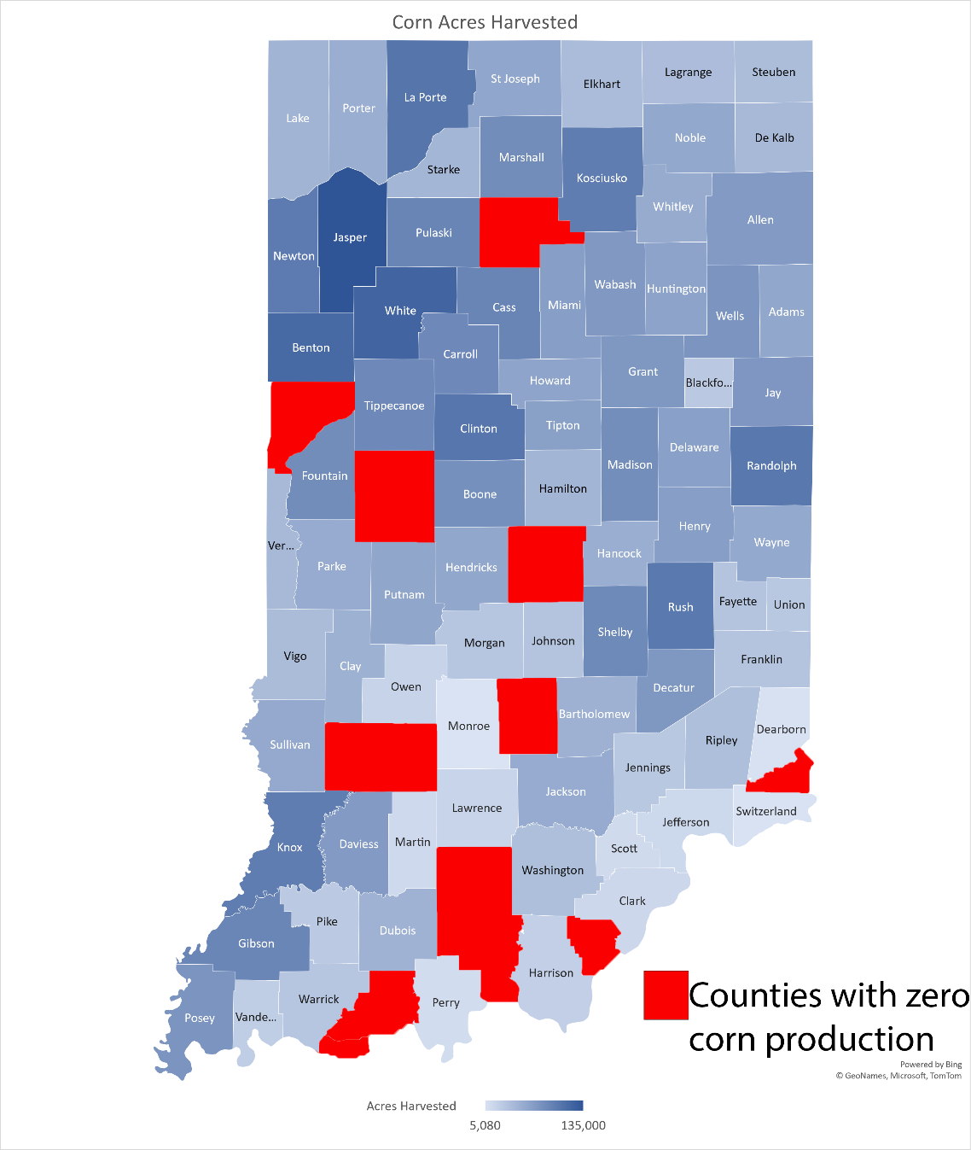

Team Member #4: Kaden Bray

My Hometown/City/Country: New Lenox, IL

Group Topic (dataset):
Include your story and visualization below.
- For my first data set covered the United States yield of soybeans. I chose to represent this data in the form of a map. This was the best way to allow for the viewers of my visualization to visibly see where most of the soybeans are being produced in the US. As seen in the visualization, soybeans are grown in the Midwest region of the US. Illinois, my home state, is the biggest producer of soybeans in the entire United States with states like Iowa following closely behind.
- My second visualization was originally a pie chart that got a lot of criticism when my team and I presented it to everyone. I had originally wanted to show that China received most of the United States exports of soybeans. After all the criticism and feedback on the chart I decided to, I changed it from a pie chart to a bar chart. Both graph types get the point I wanted to, but a bar chart is easier to read and analyze. Now when you look at the graph, I created to represent all the exports of soybeans the United States send out, it is easy to see that China is the biggest receiver and you can also see the other countries and where they stand in relation.
- I found all the data we used in this project relevant to me. I am an active member of FarmHouse Fraternity. Traditionally, there are a lot of guys in my house that come from agricultural backgrounds. A lot of them have family farms that they will return to after getting their degrees. Becoming friends with a lot of them has allowed me to visit their farms and learn a little about what life is like as a farmer. It is a very honest job that is not an easy job, but it is essential for our economy and existence entirely.
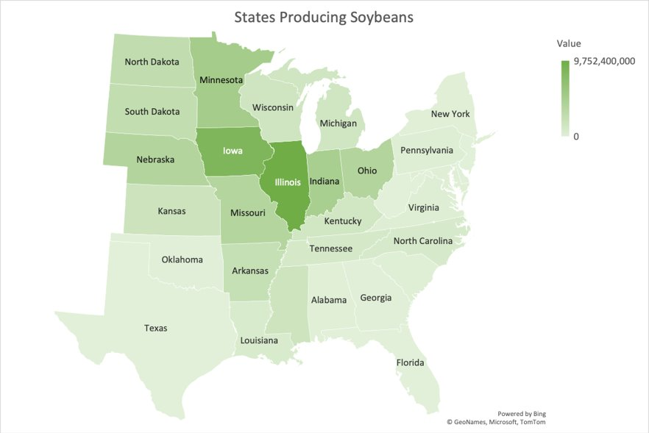

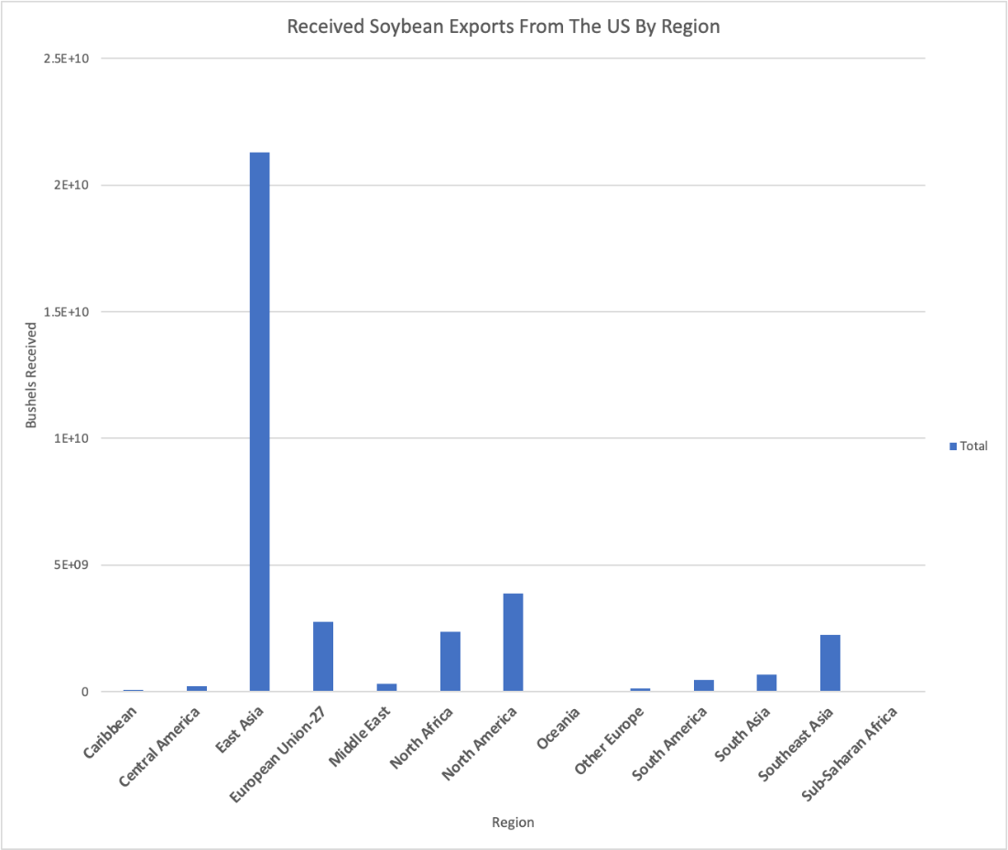

Appendix E – Team Consensus

Team Consensus
I have read and approve of the content as a representation of the team’s work and my contribution.

Team Member (full name) | Signature | Date
Tommy Hochstetler | Tommy Hochstetler | 11/09/2023
Kaden Bray | Kaden Bray | 11/09/2023
Derick Zhen | Derick Zhen | 11/24/2023
Russell Thomas | Russell Thomas | 11/25/2023

Attention:
- Make sure every member of the team has a copy of the final document.
- Save this document at TeamName_GroupProject_F2023.pdf
  - Replace TeamName with your team’s name.
- This is a group submission. Only one person from the team needs to submit the short paper.
- Upload the final version in Brightspace.
- Make sure the final version is accessible from the team’s project web page.

