Name: Derick Zhen Date: 10/20/23 Max points: 100
Lab section: Thurday Time: 1:30PM
Show your work!!!
Acquire
Gather the information needed from the Makeover Monday web page to complete this section.
Week: 35
Date: 5/08/2019 Year: 2019
Data: PCs to Become the Smallest Gaming Platform in 2018
Source Article/Visualization:
https://www.statista.com/chart/13789/worldwide-video-game-revenue-forecast/
https://www.makeovermonday.co.uk/data/
Represent
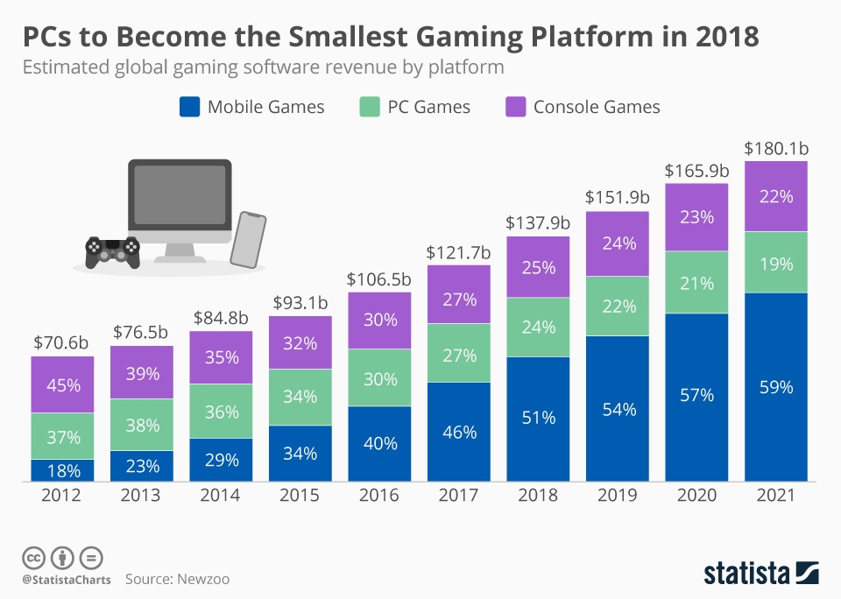

Critique
Critique the visualization: what do you like about it, dislike about it, what do you plan to do differently?
- Is well made and make sense when looking at it
- The coloring scheme matches throughout and is consistent
- An issue is that where is no Y-Axis.
- The Year is 2020 goes into 101% therefor that data can’t be trusted
- The computer picture in the top left area is somewhat unnecessary
Based on your knowledge of the Periodic Table of Visualization Methods (discussed in class), discuss which one of the 6 categories does the visualization you provided in the Represent stage falls in. Identify the method most closely related to the visualization in the Represent Stage and discuss the characteristics: overview, detail, detail AND overview, divergent thinking, convergent thinking. Refer to Readings to assist with categorizing the visualization.
Readings:
Paper: Periodic Table of Visualization Methods:
https://designsojourn.com/wp-content/uploads/periodic_table.pdf

Interactive Periodic Table of Visualization Methods
https://www.visual-literacy.org/periodic_table/periodic_table.html

Mine
What question(s) are you attempting to answer?
Despite the certain platforms are shrinking, are those platform is profitable?

Filter
Show (display, list, make it visible) the filtered data.
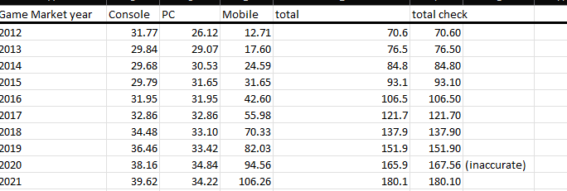
Before
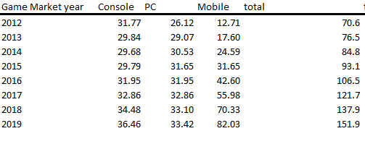
After

Stakeholders
- People interested in what platforms make the money, what sizes of the those platform are, and if they are still even profitable

What to submit: This document in PDF format only (if you do not know how to do this, see Lab 0 Exercise 1). Answer all of the questions. Save this document as: LastnameFirstInitial_CGT270F23_MM#_YYYY.pdf. Replace # with the Makeover Number (1, 2, 3, etc.), replace YYYY with the year the data is representing.
Choose the best layout for your makeover visualization: Portrait or Landscape, Remove the page of the layout that you DO NOT choose. No blank pages!

Sketch your Makeover
In the space below, sketch out your ideas for refined visualization. You must use pen/pencil and paper to sketch out your idea, then take a photo of your sketch and include it in the space below. Applying a filter to computer generated work will result in zero points for this assignment.
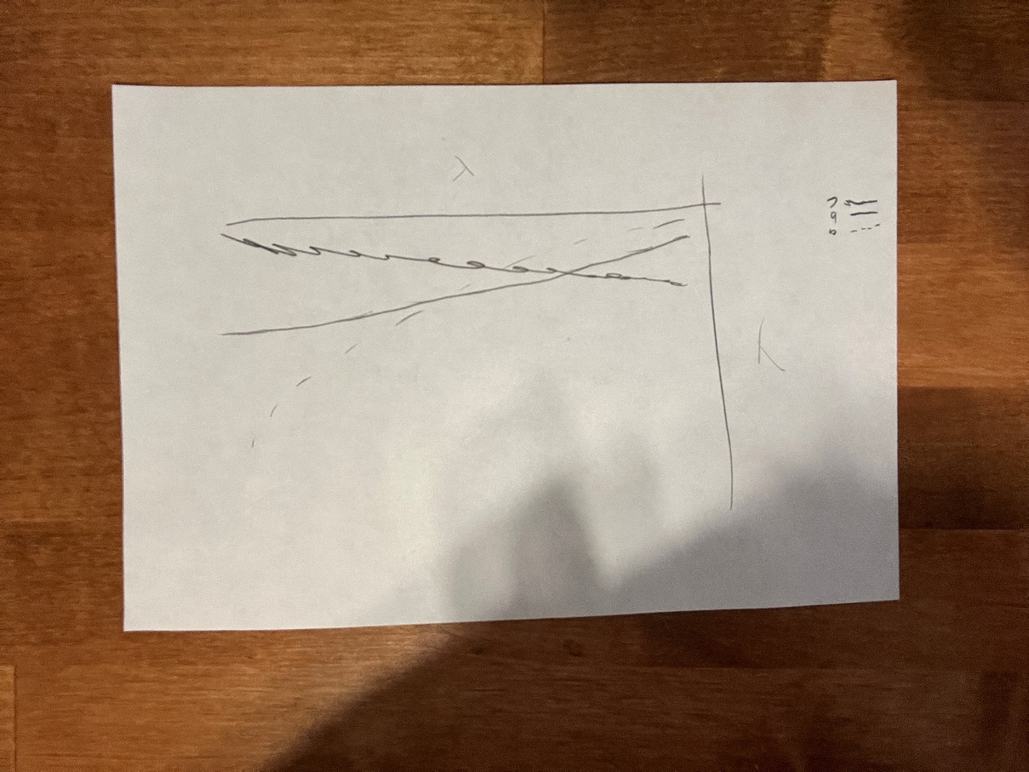

Refine (Makeover – Portrait View)
In the space below, show the computer-generated version of your sketch using the visualization tool of your choice. DO NOT draw what you sketched. The visualization should be created with the visualization tool (Tableau, Excel, Power BI, etc., of your choosing). Remember, the purpose of visualization is “insight.” Take and include a screenshot of your visualization and include it below. Use Data Visualization Best Practices (see data visualization checklist). You MUST use more advanced chart types for your makeover. Chart types that are not allowed: bar (single or stacked), pie, line charts, scatter plots, no tables.

Y-Axis (number in billions
Resources
Data Visualization Checklist:

How to give constructive criticism: https://personalexcellence.co/blog/constructive-criticism/

Sample Makeovers: https://www.makeovermonday.co.uk/gallery/

Grading Rubric
Excellent | Good | Fair | Needs Improvement
Meets ALL or most of these: Makeover is esthetically pleasing (color, perception), best practices followed (insightful), Correct dataset downloaded; provided an interesting point of view of the data; critiqued previous makeover, critique is constructive (indicates one thing that is done well, and one thing that could be done differently, what will be done to improve the visualization), assumptions (more than one) are listed.  [50 pts] | Meets MOST of these: Makeover is esthetically pleasing (color, perception), best practices followed (insightful), Correct dataset downloaded; provided an interesting point of view of the data; critiqued previous makeover, critique is constructive (indicates one thing that is done well, and one thing that could be done differently, what will be done to improve the visualization), assumptions (more than one) are listed.  [25 pts] | Consistently meets SOME of these: Makeover is esthetically pleasing (color, perception), best practices followed (insightful), Correct dataset downloaded; provided an interesting point of view of the data; critiqued previous makeover, critique is constructive (indicates one thing that is done well, and one thing that could be done differently, what will be done to improve the visualization), assumptions (more than one) are listed.  [12.5 pts] | Little to no evidence of the understanding of the data visualization process.  Lackluster makeover or no makeover.  Little effort.  [0 - 11 pts]
Sketch included: hand drawn, data vis best practices evident.  [25 pts] | Sketch included: hand drawn, lacking data vis best practices.  [12.5 pts] | Sketch included, but was generated by computer  [6.25 pts] | No sketch included.  [0 pts]
More advanced chart types used  [25 pts] | More advanced chart types used, followed most best practices  [12.5 pts] | Basic chat types used in the makeover  [6.25 pts] | Little to no improvement in visual representation of the data [0 pts]

Deductions
Description | Deduction
File naming Convention not used | -2
Did not remove unwanted/unused pages | -3
Did not use data from the assigned year | -5

