Name: Derick Date: 11/10/21 Max points: 100
Lab section: Thursday Lab Time: _1:30____________
Show your work!!!
Acquire
Gather the information needed from the Makeover Monday web page to complete this section.
Week: 17
Date: 04/25/2021 Year:2021 Data: Regional Price Parity For Each State
Source Article/Visualization:
https://howmuch.net/articles/regional-price-parities-by-state
https://www.makeovermonday.co.uk/data/
Represent
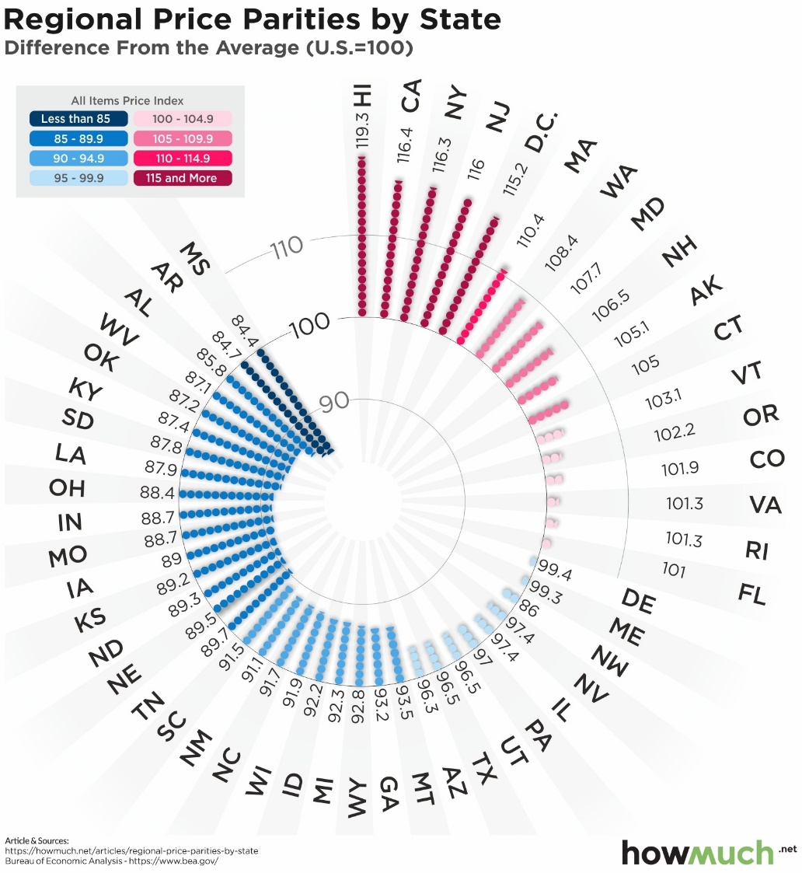

Critique
Critique the visualization: what do you like about it, dislike about it, what do you plan to do differently? Remove this text and highlighting before submitting your work.
- Doesn’t state what kind of data it’s trying to show/represent just the states and their numbers behind it
- The circular design does look interesting, just too a bit too busy to understand.
- Doesn’t show what year the data is based off.
Based on your knowledge of the Periodic Table of Visualization Methods (discussed in class), discuss which one of the 6 categories does the visualization you provided in the Represent stage falls in. Identify the method most closely related to the visualization in the Represent Stage and discuss the characteristics: overview, detail, detail AND overview, divergent thinking, convergent thinking. Refer to Readings to assist with categorizing the visualization.
Readings:
Paper: Periodic Table of Visualization Methods:
https://designsojourn.com/wp-content/uploads/periodic_table.pdf

Interactive Periodic Table of Visualization Methods
https://www.visual-literacy.org/periodic_table/periodic_table.html

Mine
How much of the prices change over the 10 years that are included within the dataset.

Filter
Show (display, list, make it visible) the filtered data.
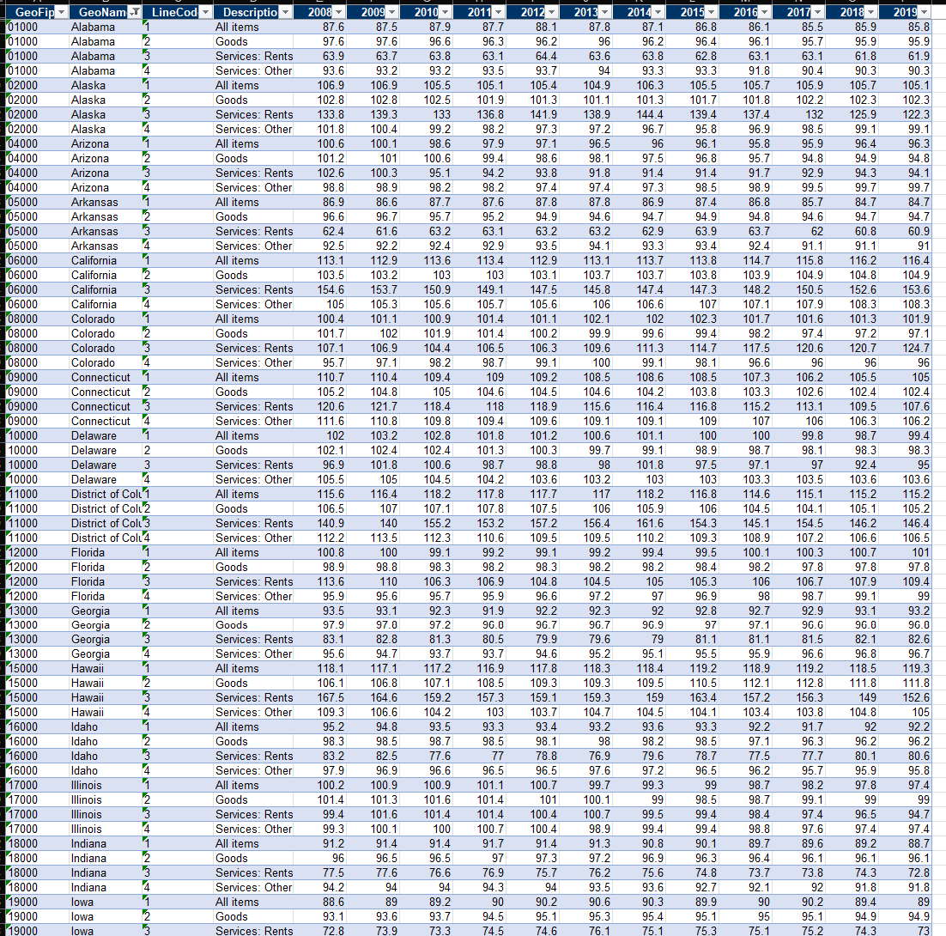
Before (too big to fit all data)
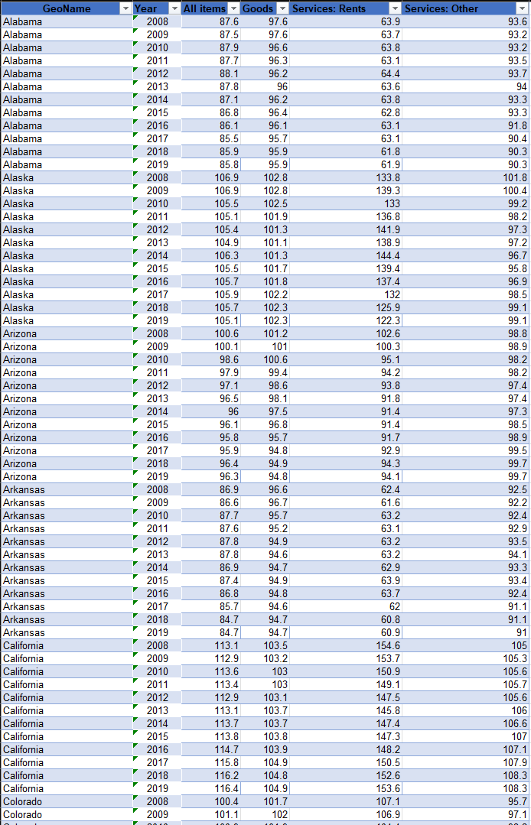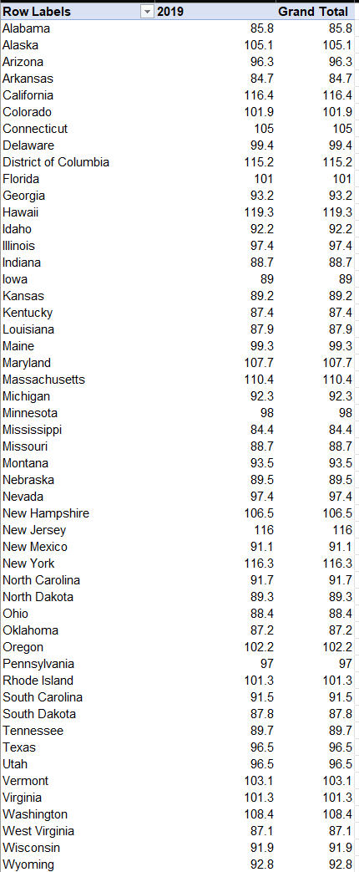
After (table and pivot table respectfully)

Stakeholders
- People who are interested in staring a business in a field that includes working with one or all of these services.

What to submit: This document in PDF format only (if you do not know how to do this, see Lab 0 Exercise 1). Answer all of the questions. Save this document as: LastnameFirstInitial_CGT270F23_MM#_YYYY.pdf. Replace # with the Makeover Number (1, 2, 3, etc.), replace YYYY with the year the data is representing.
Choose the best layout for your makeover visualization: Portrait or Landscape, Remove the page of the layout that you DO NOT choose. No blank pages!
Sketch your Makeover
In the space below, sketch out your ideas for refined visualization. You must use pen/pencil and paper to sketch out your idea, then take a photo of your sketch and include it in the space below. Applying a filter to computer generated work will result in zero points for this assignment.

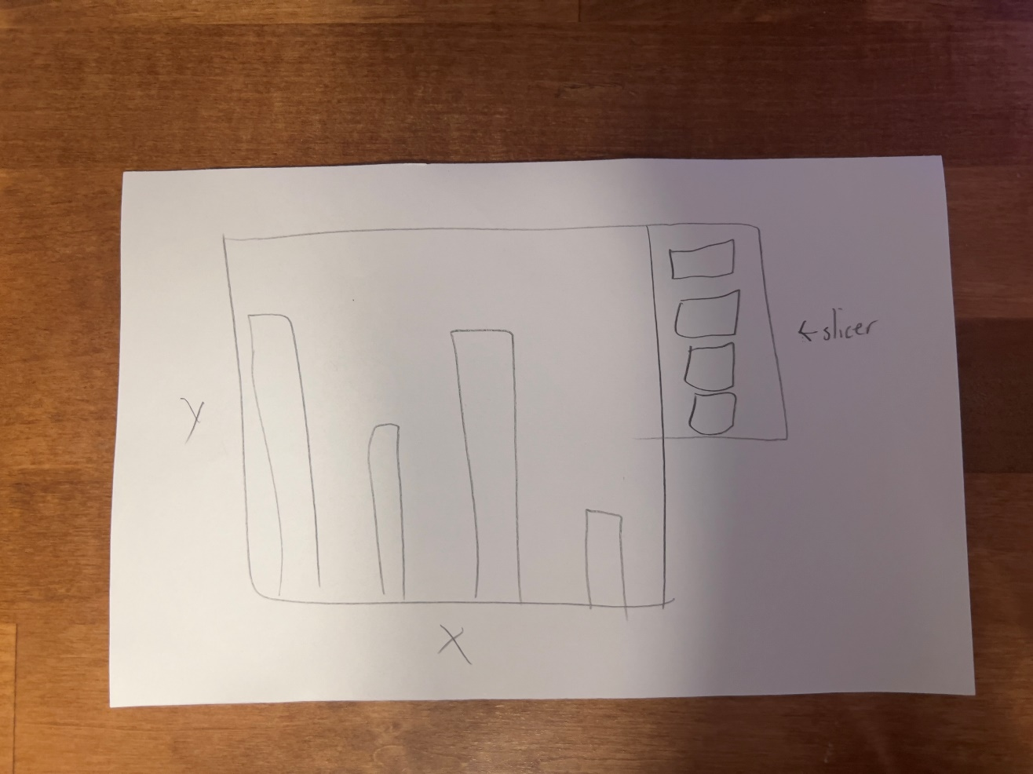

Refine (Makeover – Landscape view)
Use an additional page if necessary. Remember, the purpose of visualization is “insight.” Take and include a screenshot of your visualization and include it below. Use Data Visualization Best Practices (see data visualization checklist).
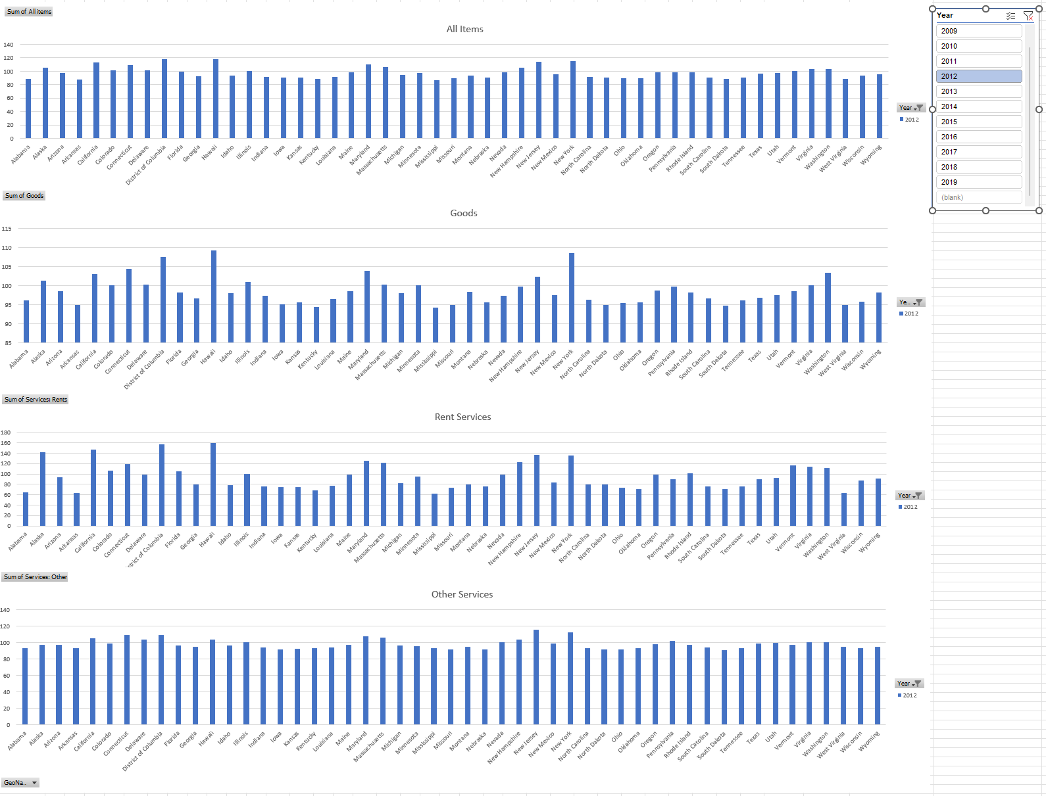
Figure Caption. <replace this text with your figure caption>.

Resources
Data Visualization Checklist:
http://stephanieevergreen.com/wp-content/uploads/2016/10/DataVizChecklist_May2016.pdf

How to give constructive criticism: https://personalexcellence.co/blog/constructive-criticism/

Sample Makeovers: https://www.makeovermonday.co.uk/gallery/

Grading Rubric
Excellent | Good | Fair | Needs Improvement
Meets ALL or most of these: Makeover is esthetically pleasing (color, perception), best practices followed (insightful), Correct dataset downloaded; provided an interesting point of view of the data; critiqued previous makeover, critique is constructive (indicates one thing that is done well, and one thing that could be done differently, what will be done to improve the visualization), assumptions (more than one) are listed.  [50 pts] | Meets MOST of these: Makeover is esthetically pleasing (color, perception), best practices followed (insightful), Correct dataset downloaded; provided an interesting point of view of the data; critiqued previous makeover, critique is constructive (indicates one thing that is done well, and one thing that could be done differently, what will be done to improve the visualization), assumptions (more than one) are listed.  [25 pts] | Consistently meets SOME of these: Makeover is esthetically pleasing (color, perception), best practices followed (insightful), Correct dataset downloaded; provided an interesting point of view of the data; critiqued previous makeover, critique is constructive (indicates one thing that is done well, and one thing that could be done differently, what will be done to improve the visualization), assumptions (more than one) are listed.  [12.5 pts] | Little to no evidence of the understanding of the data visualization process.  Lackluster makeover or no makeover.  Little effort.  [0 - 11 pts]
Sketch included: hand drawn, data vis best practices evident.  [25 pts] | Sketch included: hand drawn, lacking data vis best practices.  [12.5 pts] | Sketch included, but was generated by computer  [6.25 pts] | No sketch included.  [0 pts]
More advanced chart types used  [25 pts] | More advanced chart types used, followed most best practices  [12.5 pts] | Basic chat types used in the makeover  [6.25 pts] | Little to no improvement in visual representation of the data [0 pts]

Deductions
Description | Deduction
File naming Convention not used | -2
Did not remove unwanted/unused pages | -3
Did not use data from the assigned year | -5

